SHALOM PRIMARY SCHOOL – NAMIREMBE

TERM II HOLIDAY PACKAGE - 2020
P.1 LITERACY I
NAME……………………………………………….. STREAM………

1. Write a word with these sounds.
(a) oo ................................ (b) ch .........................................

2. Fill in the missing letter.
(a) kn___fe (b) bott___ ___

3. Write these ways of keeping food safe.
(sundrying, cooking)
(a) ............................. b).................................
4. Arrange the words to make a good sentence.
(a) weather sunny The is.
.........................................................................................................
(b) us A milk cow gives.
................................................................................................

5. Name these elements of weather.
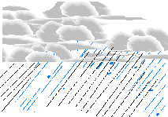  (a) | (b)

6. Make sentences using these words.
(a) mango ............................................................................................................
(b) bag ..............................................................................................................
7. Form two words with sound sh.
oe (a) ________________
sh t (b) ________________
y
8. Underline the odd member in the list.
(a) red  yellow  car  blue | (b) Polio  goat  flue  malaria

